**EZSustain**

A technological tool for more effective sustainable practices

**Requirements Analysis Document**

**Thomas Hohnke**

May 23, 2018

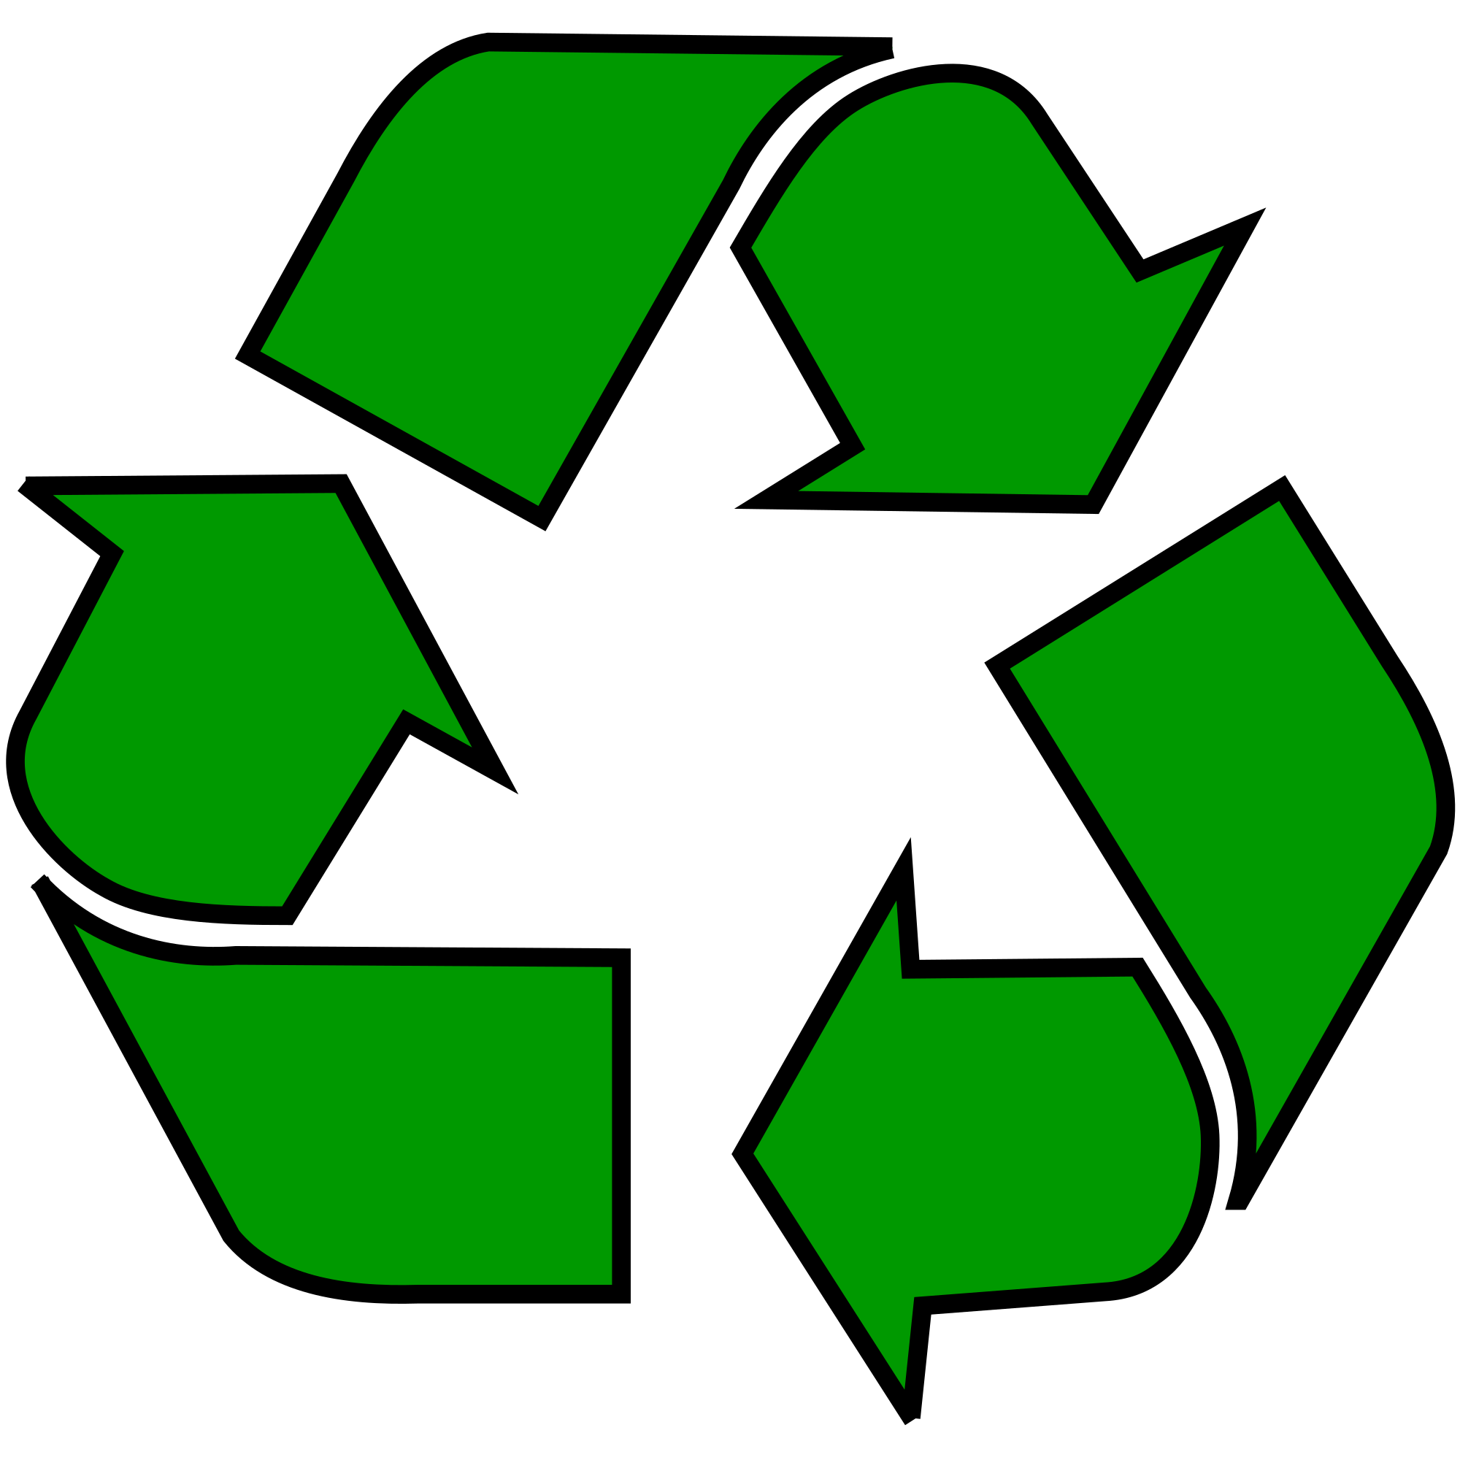

Table of Contents

Introduction 3

Proposed System 3

Functional Requirements 4

Non-Functional Requirements 4

Use Case Model 5

Use Cases 6-10

User Interface Mockup 10-11

Sample Database Tables 12

Glossary 13

# Introduction

In recent years, the world has seen a major uptake in our use of available resources. As such, there are a lot of renewable and reusable resources being wasted by being tossed in the trash, due to lack of knowledge on sustainable materials and facilities to handle these resources. This Android application hopes to change this trend by providing a way to checkout potential objects materials before they get thrown away and increase the amount of recycling done in the user’s local community.

# Proposed System

The scenario is as follows, When the user is about to throw out a specific item, they will open the app and have a list of ways to check objects. One way is using the device’s camera to scan the barcode of the packaging or material, this will read the information from the barcode, and connect to a populated database, which stores the barcode number, name of the product, materials that product is made of, and its recyclable status. If it is recyclable in the user’s defined area, it will display whether the area’s local waste management service will pick it up for recycling. If it is a material that local waste management won’t, but it can still be recycled, then the app will display a list of recycling facilities nearby that take those materials, and their location, which will use Google Maps API and can be forwarded to the app for navigational purposes. The app will also have a manual search option, where the user can use keywords typed into a search bar for a list of items matching the entered search query. The app will then proceed as described above. Also, if an item is too new to be in any database, the user may upload information about the item, and request it should be added, this will also hold true if an item’s information is inaccurate, the user may request changes to an already cataloged item in the database. If the area’s waste management information is wrong, or they have policy changes (i.e. they don’t recycle, they take new materials, etc.), A user may request this data get updated, and our team will fact check the info for accurateness and non-maliciousness.

The system proposed has the intent of allowing users to get more educated about sustainable practices, by allowing the user a quick and convenient way to check and see if a material can be recycled. This app will also be useful on college campuses who employ a sustainability project and operations, where a lot of potential waste could be saved. Also, this app fills a niche market for those looking to go greener by using products made with or using reusable or renewable resources.

# 

# Functional Requirements

The functional requirements for the system are listed below.

1. The application allows users to scan barcodes of materials.
2. The application can display information about scanned or searched items.
3. The application allows users to manually search for items by text queries.
4. The application can display area’s waste management service information and recyclability of items in that area.
5. The application can pull data from Google Maps, and display a list of recycling facilities near the area of the user if the item can’t be recycled by the users’ area’s waste management.

The above options are usable by any general user, however, to access information editing requests (such as requesting to edit area waste management services and info, or requesting new item input into a database), a user account must be created, these items, in addition to the items above, are for registered users

1. The application allows registered users to input information about an item not found in the database, and request the database(s) be updated
2. The application allows registered users to input information about their areas waste management services, and request it be changed

# Non-Functional Requirements

The non-functional requirements for the system are listed below.

1. This app doesn’t require a user account to use basic the app
2. The user may download the current cloud-based databases locally, for use offline or where data and internet access may be limited.
3. The user may save a search query when offline, so that info can be pulled when connected to a network if the item isn’t in the downloaded database or save it for a later reference.
4. All product info will be available for anyone to view
5. The Information editing portions of the app are only available to registered users with valid account credentials

# Use Case Model

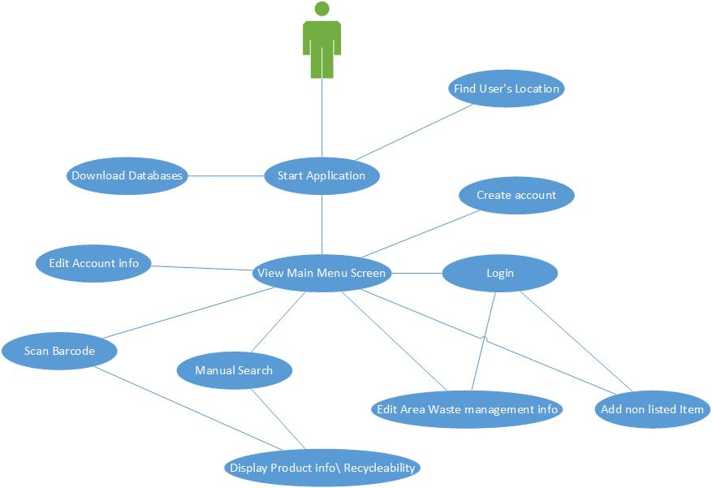

# Use Cases

1. *Use case name: Start Application*
2. Participating Actors: User
3. Entry Conditions: User has installed the application on a valid android device, the user will then press the app icon to launch the app
4. Flow of Events:
5. The main screen will come up, showing the camera search and manual search options
6. The app will ask if the user wishes to make a user account, this can be dismissed on startup by a simple clickable checkbox that, when clicked, disables the startup message for future startups
7. Exit Conditions: The user is on the main screen, and the search options loaded
8. Exceptions: The application fails to start
9. Quality Requirements: The application gets to the screen without issue
10. *Use Case Name: View main menu screen*
11. Participating actors: User
12. Entry Conditions: The app loads successfully
13. Flow of Events:
    1. The user should be looking at the main menu screen
14. Exit conditions: The main screen is loaded
15. Exceptions:
    1. The application fails to start
16. Quality Management:
17. *Use case name: Scan barcode*
18. Participating actors: User
19. Entry Conditions: The user is on the main screen
20. Flow of Events:
21. The user will press the “Scan Barcode by camera” option on the main screen
22. The device will ask permission to use the camera, the user will grant permission for the device to do so
23. The camera will be pointed in the direction of the barcode to be scanned
24. The camera will take the scanned barcode, and compare it to the product database
25. If a relevant item is available, the system will display its product info
26. Exit Condition: The user scans a barcode successfully
27. Exceptions:
28. The device doesn’t have a camera
29. The user denies usage of the camera
30. The user’s device camera is broken, or doesn’t respond to the system
31. The item isn’t in the database
32. The database can’t be accessed, either remotely or locally
33. Quality Requirements: The application can open the camera, and connect to the database
34. *Use Case Name: Manual Search*
35. Participating Actors: User
36. Entry Condition: The user is on the main screen
37. Flow of Events:
38. The user will press the “Manual search” option on the main screen
39. A search bar will appear on the top of the screen
40. The user will type a search query into the search bar, and press enter
41. The app will compare the search query to matching words in the database
42. A scrollable list will be displayed
43. The user will select the item best matching their search
44. The system will display its product info
45. Exit Conditions: The user finds the item based on their search successfully
46. Exceptions:
47. The item isn’t in the database
48. The database can’t be accessed, either remotely or locally
49. Quality Requirements: The application must be able to connect to the database, and display relevant info
50. *Use case name: Create Account*
51. Participating Actors: User
52. Entry Condition: The user is on the main screen
53. Flow of Events:
54. The user will select the menu icon in the app, then the user will select “Create Account” in the menu
55. The user will be brought to an account login screen, the user will press “First time user? Create Account” at the bottom of this screen
56. The user will be asked to then enter a valid name, and email to register for an account
57. The account will be registered with the account database
58. Exit Conditions: The user successfully created an account
59. Exceptions:
60. The account database can’t be accessed
61. The email supplied is not valid
62. Quality Requirements: The application must be able to connect to the account database for proper registration
63. *Use case name: Login*
64. Participating Actors: User
65. Entry Condition: The user is on the account login page
66. Flow of Events:
    1. The user will supply their credentials registered previously into the account database.
    2. The user will be returned to the main screen if successful
67. Exit Conditions: The user successfully logs in
68. Exceptions:
    1. The user doesn’t have an account registered with the system
    2. The user doesn’t supply the right credentials
    3. The application cannot access the accounts database
69. Quality Requirements: The app can access the accounts database
70. *Use case name: Edit area waste management info*
71. Participating Actors: User
72. Entry Condition: The user is logged into a registered account, and is on the main screen
73. Flow of Events:
    1. The user will select the “Edit area waste management info” on the main screen
    2. An info screen will appear based on where the user is currently located
    3. The user will click on the “edit info” button
    4. The user will type new information into text fields
    5. The user will press the “submit for evaluation” button
74. Exit Condition: The user successfully enters text, and presses the submit button
75. Exceptions:
    1. The user doesn’t have an account registered
    2. The user isn’t logged into the app
76. Quality Requirements:
77. *Use case name: Edit account info*
78. Participating actors: User
79. Entry condition: The user has a registered account, and is logged in
80. Flow of Events:
    1. The user will select the menu, and select “Edit account info”
    2. The user will be brought to an edit account screen, with editable text fields for username, name, email, and password.
    3. The user will select the confirm icon when finished
81. Exit condition: The user successfully edits their account information as needed
82. Exceptions
    1. The user doesn’t have a registered account
    2. The user enters the same information as before
    3. The account database cannot be accessed
83. Quality requirements: The application can pull data from and write data to the account database
84. *Use Case Name: Download Databases*
85. Participating Actors:
86. Entry Condition: The application is open
87. Flow of Events:
    1. When the app opens, a sync process occurs, syncing the local databases with the cloud databases
    2. This will occur in the background, silently
88. Exit Condition: The application successfully syncs the databases contents
89. Exceptions:
    1. The device isn’t connected to the cellular network, Wi-Fi, or Ethernet
    2. The local database becomes corrupt, and cannot sync properly
    3. The cloud database becomes corrupt, and cannot sync properly
90. Quality requirements: The application can read, write, and compare databases.
91. *Use Case Name: Add non-listed item*
92. Participating Actors: User
93. Entry Condition: The user clicks the “Add unlisted item” option on the main screen, and is logged into their user account
94. Flow of Events:
    1. The user will click on the Add unlisted item option
    2. The app will ask for the name of the item, what it is, and the materials used to manufacture the item, as well as UPC info
    3. The user will press the “Submit for approval” button, which will send the request to an application admin for approval
95. Exit conditions: The user successfully submits the request
96. Exceptions:
97. The device isn’t connected to a Cellular network, Ethernet, or Wi-Fi
98. The request fails to send to the approval administrator
99. The user isn’t logged in to their user account
100. The user doesn’t have a user account
101. Quality requirements:
102. *Use Case Name: Find User’s location*
103. Participating Actors:
104. Entry Condition: The application is loaded successfully
105. Flow of Events:
106. When the application is started, the application will find the location of the device
107. This will happen in the background
108. Exit conditions: The application successfully finds the user’s location
109. Exceptions:
110. The device isn’t connected to a cellular network, Wi-Fi, or Ethernet
111. The Google Maps navigation system is down
112. Quality Requirements
113. Use case name: Display product info\recyclability
114. Participating Actors: User
115. Entry conditions: The user searched for a product, either by camera, or by manual search
116. Flow of Events:
     1. A list of items matching the search query will be displayed
     2. The user will click on a matching item, after that, the product’s info will be displayed
117. Exit conditions: The user finds what they are looking for, or they want to go back to the search results
118. Exceptions:
119. The item doesn’t exist in the database
120. The item doesn’t exist in general
121. Quality Management:

# 

# User Interface

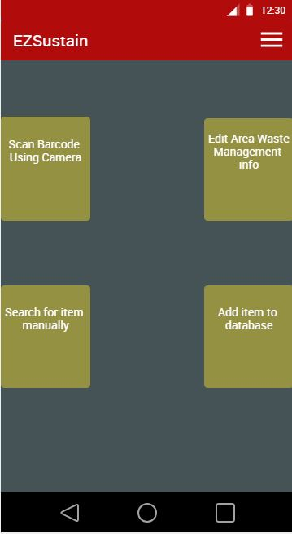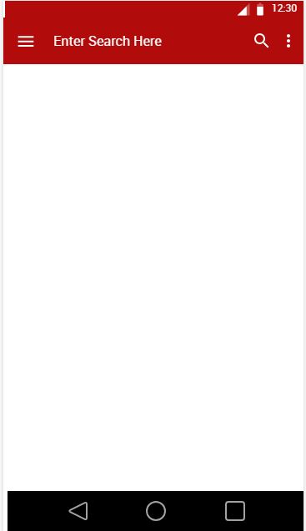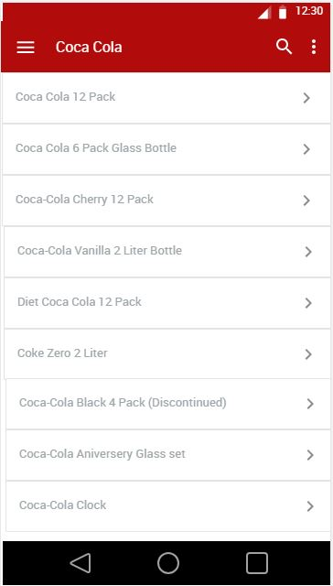

Main Screen Manual Search Manual Search Populated

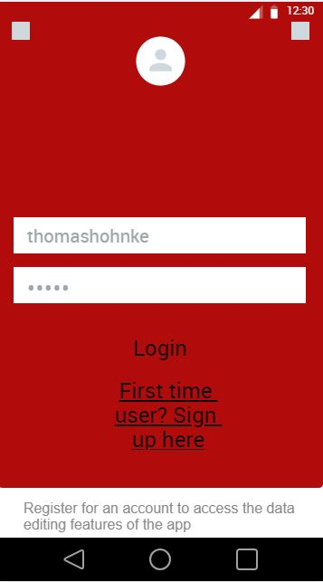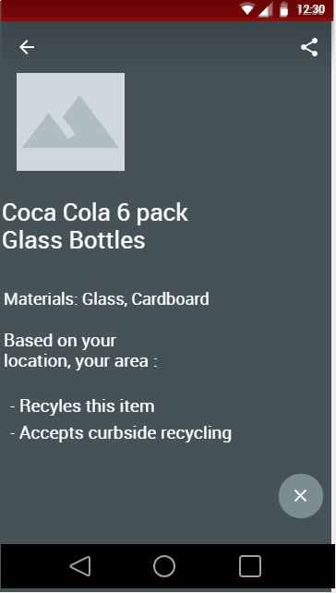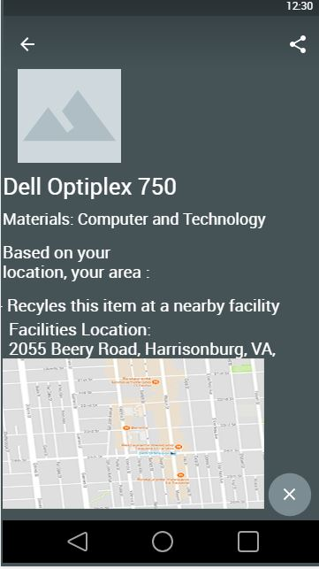

Account Login Page Material Info Page Material Info Recycle Facility

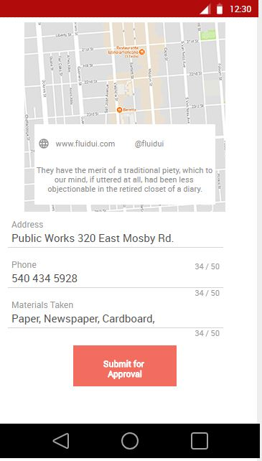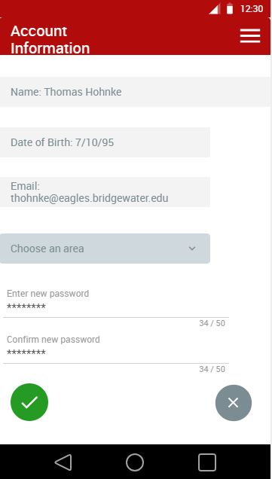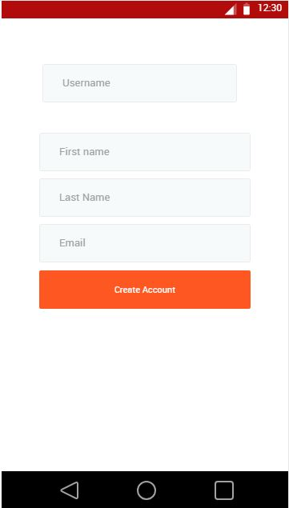

Waste Info Edit Page Account Information Page Account Creation Page

# Database Tables

User Accounts

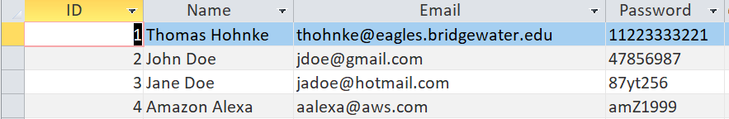

Item Info

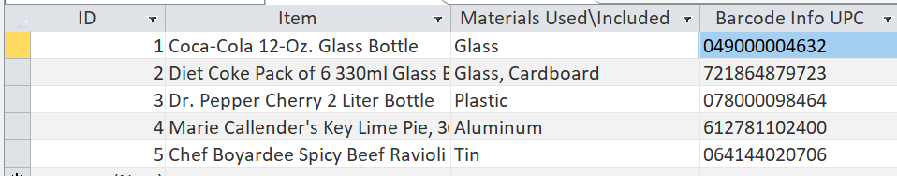

Waste Management Info

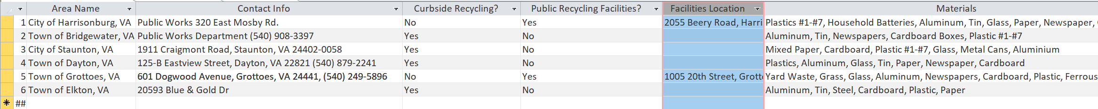

# Glossary

Android: A portable and tablet OS, based on the Linux OS, Most phones use this as their main user interface for general navigation

Cellular Data: The cell service, provided by a phone service provider

Database: A table of data that the system pulls and reads from

Main Screen: The first screen the user interacts with when they start the app

Network: The method of data connectivity, either using Wi-Fi, Ethernet, or Cellular service.

Query: Another name for a search term, i.e. what the user is searching for

Registered User: A name for a user who has created a user account and registered with the system.

Sustainability: A common business term, the ability to recycle and reuse resources

User: a participating human actively engaging with the app

User Account: An account containing the user’s personal info, such as name and email

User Name: A given name or handle for a registered user, that identifies them as a person

User Interface: The screen in which the user interacts with